HOMEWORK #4
[20 pts] (Possion’s and Laplace’s Equation Related Problem) A simple (isotropic and linear) medium with a spherical volume has a homogeneous permittivity 𝜖 and a charge density, 𝜌 in spherical coordinates. [Refer to Example 4-1, 4-2, and 4-3]

  - [5 pts] Express a scalar potential 𝑉 in this medium in terms 𝜖, 𝜌, and Laplacian operator
$∇^{2}V=-\frac{ρ}{e}$ {Scalar Poisson’s equation}
  - [5 pts] Express a scalar potential 𝑉 if the medium has no free charge
No free charge or free space indicates that $ρ=0$, hence, $∇^{2}V=0$ {Laplace’s Equation}
  - [10 pts] Find 𝐸⃗ and 𝐷⃗, if there is free space (𝜖), between the concentric spherical shells 𝑟₁, and 𝑟₂ with boundary conditions of electric scalar potential V, (𝑉₁ = 0, 𝑟₁ = 0.1 𝑚) and (𝑉₂ = 100 𝑉, 𝑟₂ = 2.0 𝑚) in this medium.
In Free space, $ρ=0, ϵ =ϵ_{0}$ {Spherical Coordinates}
Since V is not a function of θ or ϕ, Laplace’s Equation can be reduced to: $\frac{1}{R^{2}}*\frac{d}{dR}\left(R^{2}\frac{dV}{dR}\right)=0→R^{2}\frac{d^{2}V}{dR^{2}}=0$
The First integration gives $R^{2}\frac{dV}{dR}=C_{1}$
The Second Integration gives $V=-\frac{1}{R}C_{1}+C_{2}$
Using Boundary Conditions provided by the problem:
- $V_{1}=0\left[V\right], R_{1}=0.1\left[m\right]$
- $V_{2}=100\left[V\right], R_{2}=2.0\left[m\right]$
$$0=-\frac{C_{1}}{0.1}+C_{2}$$
$$100=-\frac{C_{1}}{2}+C_{2}$$
$$C_{1}=10.53\left[V⋅m\right];C_{2}=105.3\left[V\right]$$
$$\vec{E}=-∇V=-\frac{10.53}{R^{2}}\hat{a_{r}}\left[\frac{V}{m}\right]$$
$$\vec{D}=ϵ_{0}\vec{E}=\frac{1}{36π}*{10}^{-9}*\left(-\frac{10.53}{R^{2}}\hat{a_{r}}\right)\left[\frac{C}{m^{3}}\right]=\frac{117}{4*{10}^{11}*π*R^{2}}\hat{a_{r}}\left[\frac{C}{m^{3}}\right]$$

- [20 pts] (Steady electric current, understanding of volume current density, mobility, conductivity, and basic ohm’s law) As shown below, a conducting medium with a length, l, a cross-sectional area, S, a conductivity, σ, and a charge density, ρ is under electric field intensity, 𝑬⃗. The volume current density, 𝑱⃗ in the medium is induced by 𝑬⃗.
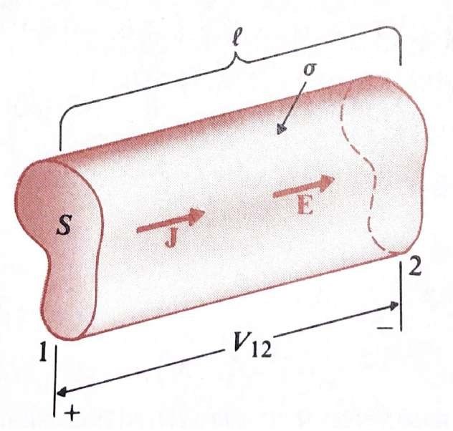
  - [3 pts] If the total number of N charges (q) is moving due to the applied scalar electrical potential V, express the drift velocity, of the charges in terms of current, I.
If we let the velocity of charge, q, is $\vec{u_{q}}$ the total current density of the conducting medium with a cross-sectional surface, S, will be $J\left(\frac{I}{S}\right)=Nq*\vec{u_{q}}→\vec{u_{q}}=\frac{I}{Nq*S}$
  - [7 pts] Explain “Electrical Mobility, 𝝁_{𝒆}” if a negative charge electron, –e, is biased by an electric field intensity, 𝐸⃗ induced by the applied electrical potential 𝑽_{𝟏𝟐} as shown above Figure. In addition, express 𝝁_{𝒆} as a function of σ. (𝒖_{𝒆}⃗: Drift Velocity of electron)
The ability of a charged particles electron holes and ions to move through medium in response to an externally applied electric field. Velocity (drift velocity) of electrons, $u$𝑒 based on the physical definition of “electrical mobility”. $\vec{u_{e}}=μ_{e}\vec{E}; -μ_{e}:electron Mobility$
$$=-μ_{e}\frac{V_{12}}{l}$$
$$\vec{J}=σ\vec{E}=-e\vec{u_{e}}=-e\left(μ_{e}\right)\vec{E}→σ=-e*μ_{e}$$
  - [10 pts] To investigate the physical relationship between d-c resistance, R, and conductivity, σ of a conducting medium, two kinds of conducting media, Cu, and Au with 𝝈_{𝑪𝒖} = 𝟓.𝟖×𝟏𝟎^{𝟕}[S/m], and 𝝈_{𝑨𝒖} =𝟑.𝟓×𝟏𝟎^{𝟕}[S/m] respectively, were used with the same structural geometry as shown above Figure Find the total heating power ratio ${P_{Au}}/{P_{Cu}}$, if the each medium biased by the same current I = 2 mA induced by the same electromotive force (emf), 𝑽_{𝟏𝟐}.
Total Heating Power, P: $P=I^{2}R$→$P=I^{2}\left(\frac{l}{σS}\right)$
$$I, l, S are the same due to same geometry: \frac{P_{Au}}{P_{Cu}}=\frac{σ_{Au}}{σ_{Au}}=\frac{5.8}{3.5}≅1.65714$$

- [20 pts] (Practical problem of finding conductance in cylindrical coaxial line using Ohm’s Law) The radii of the inner and outer conductors of coaxial cable of length 𝒍 are a and b, respectively (below Figure). The insulation material has conductivity 𝜎. Obtain an expression for G, the conductance per unit length of the insulation layer.
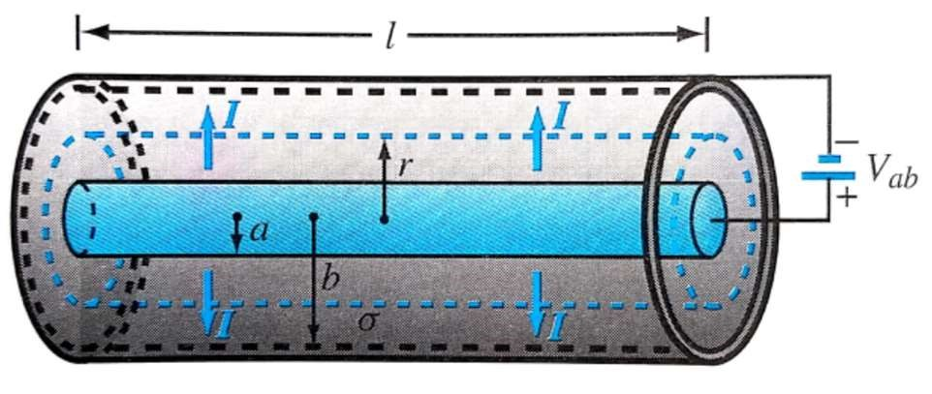
Let I be the total current flowing from the inner conductor to the outer conductor through the insulator material. At any radial distance, r, from the axis of the center conductor, the area through which the current flows is $A=2πrl$. Hence, $\vec{J}=\frac{l}{A}\hat{a_{r}}=\frac{I}{2πrl}\hat{a_{r}}, \vec{J}=σ\vec{E}→\vec{E}=\frac{I}{2πσrl}\hat{a_{r}}$
Therefore, the voltage difference between a & b, can be expressed as $V_{ab}=-\int_{b}^{a}{E⋅dl}=$
$-\int_{b}^{a}{\frac{I}{2πσl}\frac{1}{r}\hat{a_{r}}⋅\hat{a_{r}}dr}→\frac{I}{2πσl}\ln\left(\frac{b}{a}\right)$, hence the conductance per unit length, $G=\frac{2πσ}{\ln\left(\frac{b}{a}\right)}$,

- [20 pts] (Applications of Boundary Conditions and Current Density in Multi-Dielectric Capacitors discussed in Chapters 5-2-3 & 3-4-12, 13) An emf 𝒗 is applied a capacitor of area S₁, and S₂, respectively as below. The space between the conducting plates is filled with two different lossy dielectric of thickness d, permittivities, 𝝐_{𝟏} and 𝝐_{𝟐}, and conductivities 𝝈_{𝟏} and 𝝈_{𝟐}, respectively.
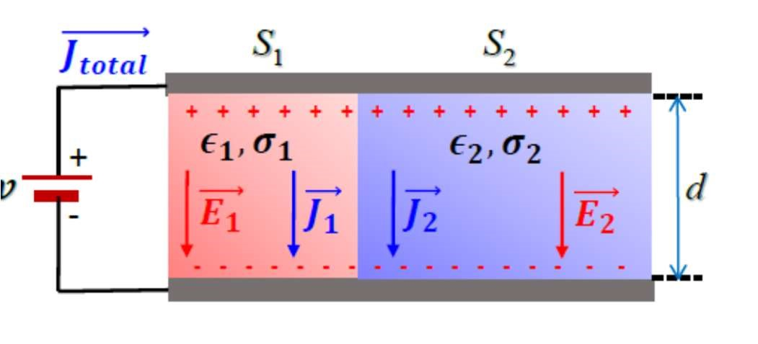
  - [15 pts] Find the current densities, 𝑱_{𝟏}⃗, 𝑱_{𝟐}⃗, and the current density, 𝑱_{𝒕𝒐𝒕𝒂𝒍}⃗ induced by an emf 𝑣.
Based on the figure, two parallel capacitors are connected to each other, so the leakage resistance, R, is also in parallel.
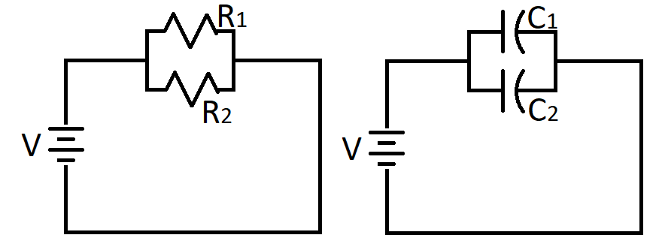
$$J_{total}=J_{1}+J_{2}, C_{total}=C_{1}+C_{2}, R_{total}=\frac{R_{1}R_{2}}{R_{1}+R_{2}}$$
$$I_{total}=\frac{\left(R_{1}+R_{2}\right)V}{R_{1}R_{2}}=\frac{\left(\frac{d}{J_{1}S_{1}}+\frac{d}{J_{2}S_{2}}\right)V}{\frac{d}{σ_{1}S_{1}}*\frac{d}{σ_{2}S_{2}}}=\frac{\left(σ_{1}S_{1}+σ_{2}S_{2}\right)V}{d}→R_{total}=\frac{d}{\left(σ_{1}S_{1}+σ_{2}S_{2}\right)}$$
$$I_{1}=\frac{R_{2}}{R_{1}+R_{2}}*I_{total}=\frac{\frac{d}{σ_{2}S_{2}}}{\frac{d}{σ_{1}S_{1}}+\frac{d}{σ_{2}S_{2}}}*\frac{\left(σ_{1}S_{1}+σ_{2}S_{2}\right)}{d}V=\left(\frac{σ_{1}S_{1}}{d}\right)V$$
$\vec{J_{1}}=\frac{I_{1}}{S_{1}}=\frac{σ_{1}}{d}V , \vec{J_{2}}=\frac{I_{2}}{S_{2}}=\frac{σ_{2}}{d}V$, thus $\vec{J_{total}}=\frac{σ_{1}+σ_{2}}{d}V$
  - [5 pts] Find and express the electric field intensities, 𝑬_{𝟏}⃗ and 𝑬_{𝟐}⃗ in both dielectrics as a function of 𝑱𝒕𝒐𝒕𝒂𝒍⃗.
$$\vec{E_{1}}=\vec{E_{2}}=\vec{E}; \vec{E}=\frac{V}{d}=\frac{1}{d}\left(\frac{d}{σ_{1}+σ_{2}}\right)*\vec{J_{total}}=\frac{1}{σ_{1}+σ_{2}}\vec{J_{total}}$$

- [20 pts] (Finding R or C from electrostatics in terms of 𝝈 and 𝝐, Refer to EXAPMLES 5-2-3 in Chapter 5-2-12 and 3-4-9 in Chapter 3-4) A spherical capacitor consists of an inner conducting sphere of radius 𝑹_{𝒊} and outer conductor with a spherical inner wall of radius 𝑹_{𝟎}. The space in between is filled with a dielectric permittivity 𝝐, as shown below.
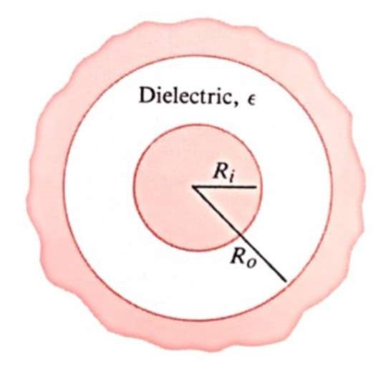
  - [6 pts] Determine the Capacitance, C.
$$C=\frac{Q}{V}, and V=-\int_{R_{o}}^{R_{i}}{\frac{Q}{4πϵR^{2}}dR}=\frac{Q}{4πϵ}\left(\frac{1}{R_{i}}-\frac{1}{R_{o}}\right)$$
$$C=\frac{Q}{\frac{Q}{4πϵ}\left(\frac{1}{R_{i}}-\frac{1}{R_{o}}\right)}=\frac{4πϵ}{\frac{1}{R_{i}}-\frac{1}{R_{o}}}$$
  - [6 pts] Determine the “Stored Electric Energy, 𝑾_{𝒆}, if charges +Q and –Q are induced on the inner and outer conductors
$$W_{e}=\frac{1}{2}CV^{2}=\frac{1}{2}QV=\frac{Q^{2}}{2C}\left[J\right]$$
$$W_{e}=\frac{1}{2}QV=\frac{1}{2}Q*\frac{Q}{4πϵ}\left(\frac{1}{R_{i}}-\frac{1}{R_{o}}\right)=\frac{Q^{2}}{8πϵ}\left(\frac{1}{R_{i}}-\frac{1}{R_{o}}\right)$$
  - [8 pts] Find the leakage resistance 𝑹_{𝒍𝒆𝒂𝒌}, if the dielectric medium has conductivity, 𝝈.
$$R=\left(\frac{ϵ}{σ}\right)\left(\frac{1}{C}\right)=\left(\frac{ϵ}{σ}\right)\left(\frac{\frac{1}{R_{i}}-\frac{1}{R_{o}}}{4πϵ_{0}}\right)=\frac{\frac{1}{R_{i}}-\frac{1}{R_{o}}}{4πσ}$$

